How to internalize demo deployments:

Open Visual Studio Code and right-click on the folder containing the deployment you want to internalize. In this example, “msfirewall”:

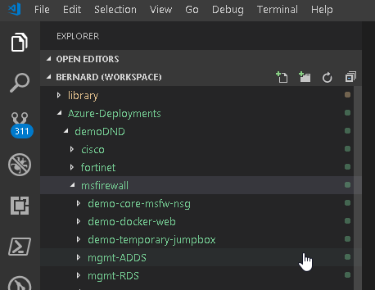

Type “Demo” in 1st field, type desired name in 2nd field (like “DND”) and select the 1st icon on 1st field to match based on Case:

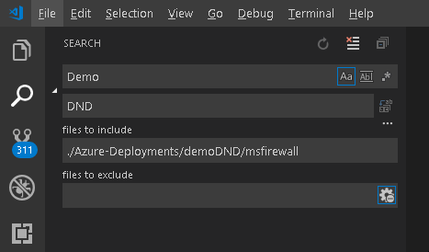

If all look good click on the icon at the end of the 2nd field to replace instances:

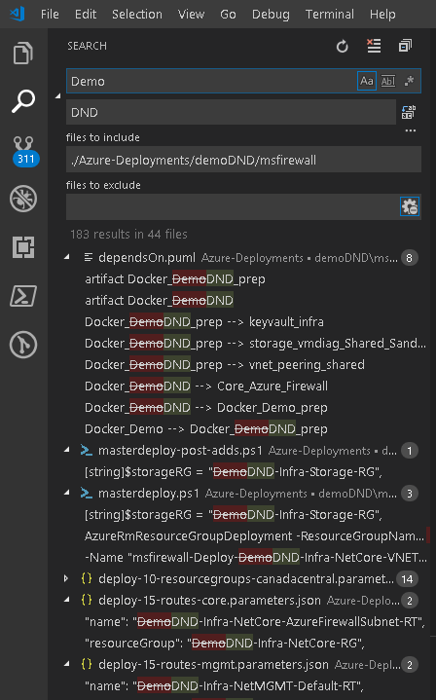

Click “Replace”

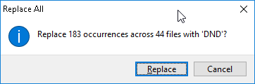

Repeat the search but with “demo” and “dnd” all in lowercase:

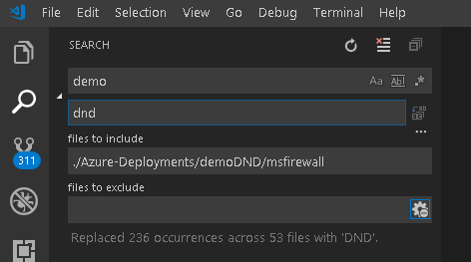

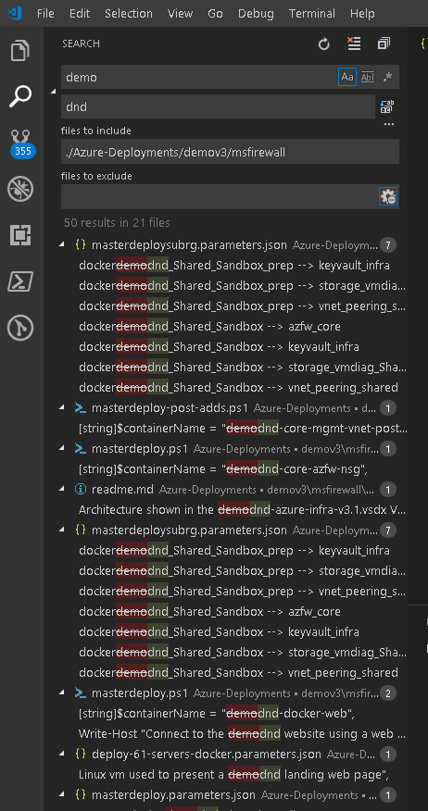

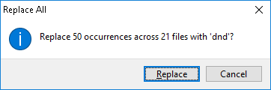

And finally with “DEMO” and “DND” all in upper case:

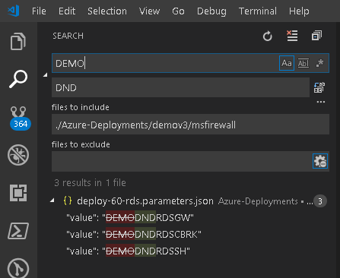

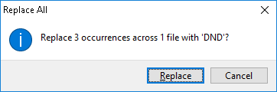

All done. You are ready to deploy.